What is Hadoop?

an open source **software platform** for **distributed storage** and **distributed processing** of very large data sets on computer clusters built from **commodity hardware** - Hortonworks

**Software platform** is a bunch of software that runs on a cluster of computers, Hadoop grabs the power of multiple pcs instead of running software on a single pc.

bigdata refers to getting terabytes of information every day or even more.

So, inorder to store the terabyte sof information we use **distributed storage**. it is like terabytes of data distributed across all of the hard drives in your cluster as one single file system.

if one of the harddrives present in the computer crashes into the flames. hadoop gonna able to retrieve it for you because it keeps backup copies of all your data on other places in your cluster of computers and its very reliable.

Not only hadoop stores your data in a distrubuted storage it can also **distribute the processing of data** as well. In this way, you can retreive the data you want very quickly instead of waiting for days to retrieve data from a single computer. it is using divide and conquer problem across all the PCs in a cluster.

clusters built from **commodity hardware**, that means aws, google cloud platform or microsoft azure that sell cloud services so that you cant rent off hardware which is used in a hadoop cluster.



* + HDFS - Hadoop Distributed File System, distributed data storage of hadoop
  + YARN - Yet Another Resource Negotiator, manages the resources on your computing cluster
  + MapReduce - programming model that allows you to process your data across
  + Pig - High Level programming API, SQL style syntax, transforms the script into something that will run on map reduce.
  + Hive - its just like a database, similar to pig but it really looks like a sql database
  + Ambari - gives a view of your cluster. sits on top of everything. ambari belongs to hortonworks
  + Mesos - alternative to yarn
  + Spark - sitting at the some level of map reduce, handle sql queries, streaming data in real time, it can do machine learning.
  + Tez - uses some techniques of spark, produces optimal plans for executing queries ( uses directed acyclic graph, its a leg up on what map reduce does) , hive through tez can be faster than hive through map reduce
  + Hbase - NoSql DATABASE, meant for very large transaction rates, fast way of exposing data , so that mapreduce/ spark can use it to transform it
  + Storm - way of processing streaming data in real time, update ml models, transform data in all real time
  + Ooozie - scheduling jobs on your cluster, so when you have more complicated operations that require loading data into hive and then integrating with the pig and may be querying with SPARK and then transforming the results into Hbase OOozie can manaze that all for you.
  + ZooKeeper - Coordinating everthing on your cluster, keeping track of which nodes are up and down
  + Data Ingestion
  + Sqoop - RDMS TO HDFS
  + Flume - Collects Web Logs in Real time, ingest them into your cluster.
  + Kafka - collect general data in real time and ingest them into your hadoop cluster.
  + External Data Storage
  + MySQL - RDMS, IMPORT AND EXPORT the data from sqoop into your cluster and write queries.
  + cassandra - columnar data, exposing data real time
  + mangoDB - columndar data, exposing data real time
  + mysql, cassandra, mangoDB can all integrate with your cluster
  + Apache Drill - interactive query engine, works with cassandra, mangodb, habse, sql.
  + Hue - Interactive query engine, works well with hive and hbase.
  + Apache Phoenix - Interactive query engine, similar to apache drill , gives you ACID guarentees.
  + Presto - query engine, execute queries across your entire cluster
  + zeppeline - notebook type approach to the UI, query engine

**Hadoop Distributed File System / Why Hadoop?**

Data is large now a days, whether the data is stock market or contains the dna information.

**Scientists say all the world’s data can fit on a DNA hard drive the size of a teaspoon**

- <https://qz.com/345640/scientists-say-all-the-worlds-data-can-fit-on-a-dna-hard-drive-the-size-of-a-teaspoon/>

HDFS Handles big files, it is really optimized.

it handles them by breaking the big files into the blocks. each block is 128mb by default so we can understand even a block is large

store the blocks across several commodity hardwares. it will actually store than one copy of each block inorder to handle failure.

**HDFS Architecture**

it consists of a single name node and several data nodes

Name Node - it keeps tracks of where all blocks live. it keep tracks of edit log. edit log stores whats being modified, moved, created. basically, it keep tracks of everthying that is present in datanode.

Data Node : it stores each block of each file, they also talk to each other maintain the copies of blocks.

In HDFS to read a file, the client node first talks to the name node which directs the client node to the appropriate data node. Name node also determines the most efficient data nodes for you to reach from your client.

To write a file, the client tells the name node, name node creates a new entry. name node acknowledges client that go create your file. client node then talks to a single data node about its file. then the data nodes talk to each other to replicate the blocks of that file across multiple nodes. sends the acknowledgements saying ok to client node and finally back to name node. then name node records the fact that this new file exists and it is stored in a replicated manner across data nodes.

**What if namenode crashes ?**

Back up your metadata constantly. most simplest thing to do. disadvantage is because of the lag there will be some loss of information.

maintain a merged copy of edit log (secondary node) from your primary name node.

HDFS Federation - each namenode manages a sepcific namespace volume. so we will loose only some information if one of the nodes fail. it is better than entire hdfs cluster going down.

**HDFS High Availability**

Hot standby namenode using shared edit log

Zookeeper tracks active namenode

uses extreme measures to ensure only one namenode is used at a time.

**Ambari Interface**

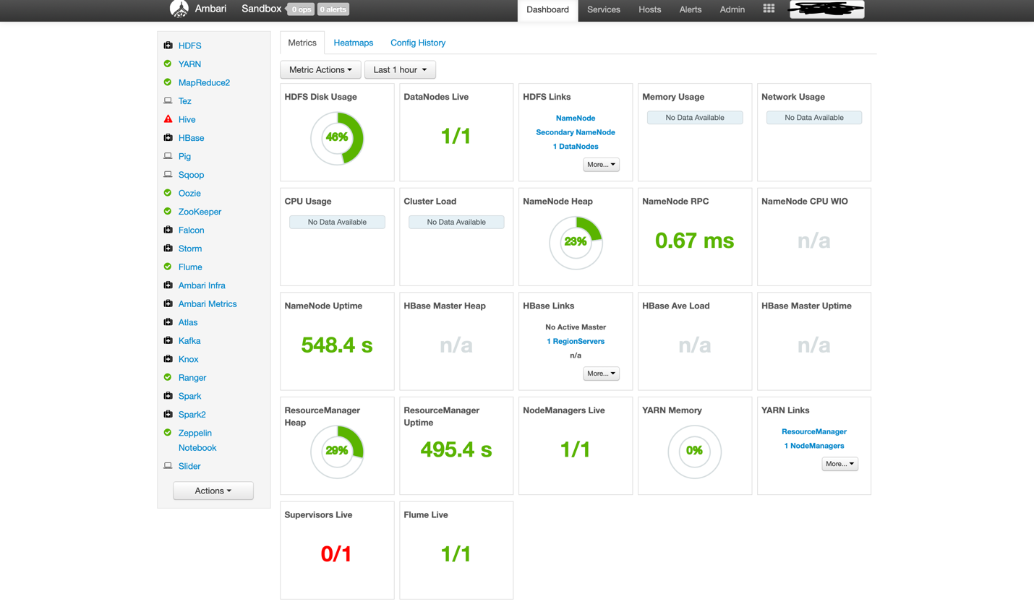

Click files view to view the entire HDFS file system thats running on our hadoop cluster. this file view allows us to view and manipulate all the files in our HDFS file system.

2) Using command line:

On putty/terminal connecting to the sandbox server can use commands like

* hadoop fs -mkdir directory - to create a directory on hdfs
* hadoop fs -ls to see the list of directories
* wget http://........ link to get data from an online source
* hadoop fs -copyFromLocal file directory/file to copy from one place to other
* hadoop fs -rm file directory/file to remove a file
* hadoop fs -rmdir directory to remove a directory
* hadoop fs to get list of commands

MapReduce

Distributes the processing of data on your cluster.

there are two things that mapreduce do?

1)map - it maps data. -> key value (transform your data)

2)reduce - it reduces data. (aggregate your data)

it also deals with node failure, application master monitors your mappers and reducers on each partition

A simple example below illustrates the concept of mapreduce on a cluster.

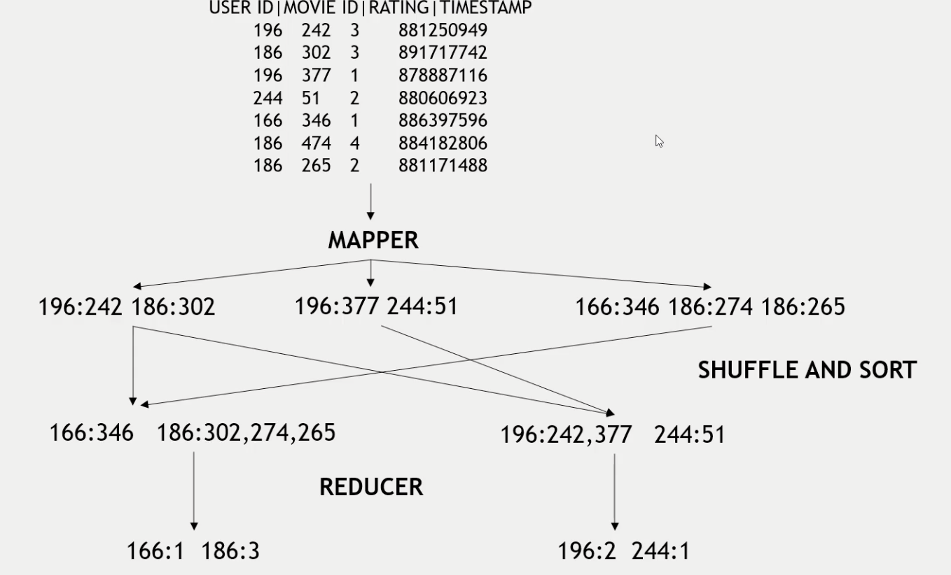

* Dataset gets chopped up into three parts. first two lines sent to one node, second two lines sent to second node and remaining lines sent to remaining node.
* each node here can be a computer, multiple machines working together takes the advantage of hadoop's distributed storage and distributed processing.
* mapper transforms each individual line of the data into a key value pair.
* Here, key is the user id and value is the movie id for each individual rating.
* shuffle and sort will merge all the duplicate keys into a single unique key and sort those keys. then reducer is giving out the length for each key i.e number of movies rated by the each user.



So when you kick things off from a client node,

resource manager keep tracks of status of different computers, application master keeps tracks of all of your tasks and node manager keep tracks of individual pcs as a whole. they all talk to data present in the HDFS.

Node closer to the data will be given high priority for a task by the resource manager.

Natively map reduce code is written in java but we can write them in any language such as python with help of concept of streaming.

**How to handle failure :**

Application master monitors worker tasks for errors or hanging

restarts as needed

preferably on a different node

what if the application master goes down?

YARN can try to restart it

what if an entire node goes down?

this could be the appication master

the resource manager will try to restart it on different pc

what if the resource manager goes down?

can set up "high availability" using zookeeper to have a hot standby (second backup resource manager)

Map reduce, its been largely superseded by technologies like Spark or higher level tools that actually let you issue sql style queries such as hive to your cluster

Run Locally

python script.py data-filename

Run with Hadoop

python script.py -r hadoop --hadoop-streaming-jar /usr/hdp/current/hadoop-mapreduce-client/hadoop-streaming.jar filename

if the file is not in local system but on the hdfs cluster then

python script.py -r hadoop --hadoop streaming-jar /usr/hdp/current/hadoop-mapreduce-client/hadoop-streaming.jar hdfs://........path